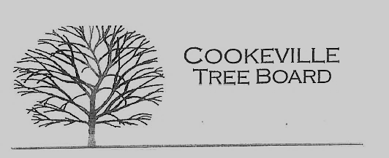

City of Cookeville Tree Board Agenda
February 7, 2024 at 12:00pm

- Approval of Minutes

- Jeff Fitzpatrick – city trees & construction
- Sid Lepley – Cookeville Jr Women’s Club Grant Application
- Jaime Nunan – Canopy Study Proposal
- Board Vacancy
- Additional Business

