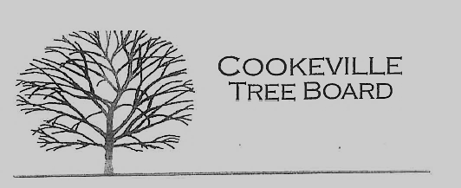

City of Cookeville Tree Board Agenda
October 4, 2023 at 12:00pm

- Approval of Minutes

- Tree Board Activity – Fall Tree Distribution
- Historic Tree Program
- TAEP Grant
- Board Vacancy
- Tennessee Urban Forestry Conference – Spencer TN 10/12-10-13
- Additional Business

