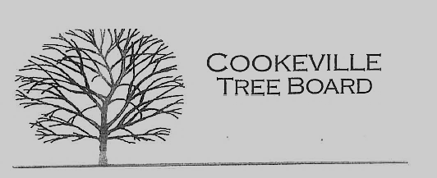

City of Cookeville Tree Board Agenda
June 7, 2023 at 12:00pm

- Approval of Minutes

- Tree Board Activity – Fall Tree Distribution
- Historic Tree Program
- Additional Business

