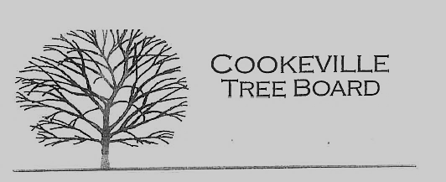

City of Cookeville Tree Board Minutes
April 5, 2023 at 12:00pm
In attendance: Jeff Fitzpatrick, Jeff Thompson, Douglas Airhart, Susanna Clouse, Tony Stone, Delayne Miller, Jaime Nunan.
- Approval of Minutes

- Arbor Day Tree Planting Locations
Board Members discussed planting locations to use for the required Arbor Day Celebration activity. Jeff F. and Jaime agreed on replacing trees that had been removed at Park View ball fields and will coordinate that project.

- Tree Board Activity – Fall Tree Distribution
Board members discussed using excess funds to host a tree distribution in the Fall if the Arbor Day Foundation does not choose to sponsor the city going forward. The funds that were allocated for tornado canopy recovery since 2020 may be ending.

- Tree Board Arboretum Project - Walnut Park
Board members discussed possibly making Walnut Park an arboretum now that it has an expanded walking trail and more public entrance.

- Update on Historic Tree Program
Delayne informed board members that Austin has created a template for the program and will bring it to the next board meeting.

- Additional Business

Board members discussed proactive fall tree activities such as school tree plantings and educational utility bill inserts.
Meeting Adjourned 12:46pm

