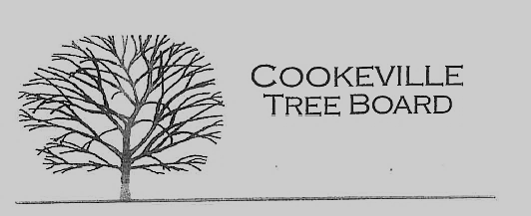

City of Cookeville Tree Board Agenda
April 5, 2023 at 12:00pm

- Approval of Minutes

- Arbor Day Tree Planting Locations
- Tree Board Activity – Fall Tree Distribution
- Tree Board Arboretum Project - Walnut Park
- Update on Historic Tree Program
- Additional Business

