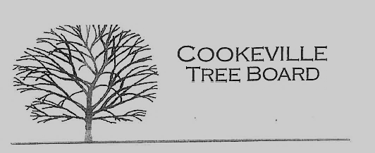

City of Cookeville Tree Board Minutes
December 7, 2022 at 12:00pm
In attendance: Guy Zimmerman, Jeff Fitzpatrick, Douglas Airhart, Ken Young, Susanna Clouse, Tony Stone, Delayne Miller, Jaime Nunan, Blake Mayo

- Approval of Minutes
No Quorum for meeting on 10/05/2022

- Vacant Positions
- Arbor Day Award Presentation
Board members will present the Arbor Day Award to Bob Bell 12/9/22 at 11:00am
- Tree Board Activities/Program ideas
Tree Board members discussed activities for the board for the upcoming year. These ideas included, CHS art competition, creating additional arboretums, and a historic tree registry.

- Additional Business

Board members discussed the best possible options for the removal of the historic sycamore at west end park. Ideas included donating wood for a park project and consulting with neighbors before removal.

Meeting Adjourned 12:28

