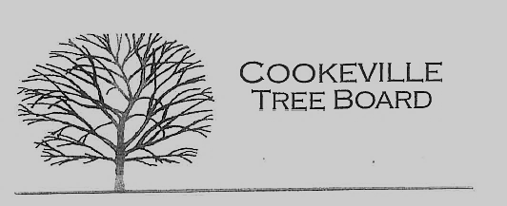

City of Cookeville Tree Board Agenda
December 7, 2022 at 12:00pm

- Approval of Minutes
No Quorum for meeting on 10/05/2022

- Vacant Positions
- Arbor Day Award Presentation
- Tree Board Activities/Program ideas
- Additional Business

