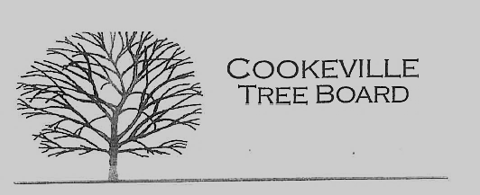

City of Cookeville Tree Board Agenda
October 5, 2022 at 12:00pm

- Approval of Minutes
- Vacant Positions
- Arbor Day Award Presentation
- Arbor Day Foundation Community Recovery Tree Give Away - November 4th
- Tree Board Activities/Programs
- Additional Business

