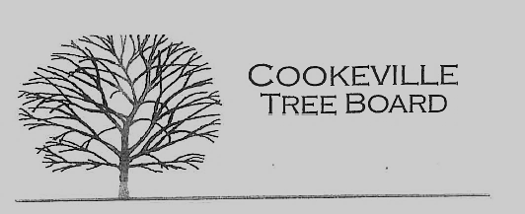

City of Cookeville Tree Board Agenda
February 2, 2022 at 12:00pm

- Approval of Minutes
- Heritage Trees
- Vacant Position
- Arbor Day Awards
- Arbor Day Foundation Community Recovery Tree Give Away
- Additional Business

