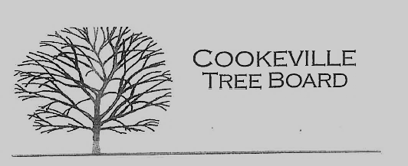

City of Cookeville Tree Board Agenda
August 3, 2022 at 12:00pm

- Approval of Minutes
- Heritage Trees
- Vacant Positions
- Arbor Day Award Presentation
- Arbor Day Foundation Community Recovery Tree Give Away
- TAEP Grant FY 22-23
- Jeff Littrell Contributions & Memorial
- Urban Forest Strike Team(UFST) Training March 29-30, 2023
- Additional Business

