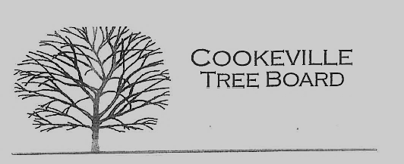

City of Cookeville Tree Board Minutes
August 3, 2022 at 12:00pm
In attendance: Blake Mayo, Ken Young, Jaime Nunan, Guy Zimmerman, Delayne Miller, Jeff Thompson, Douglas Airhart. and Tony Stone.
Called to Order 12:03pm
- Approval of Minutes
- Heritage Trees
- Vacant Positions
One vacancy for an appointed member is still available on the board. Douglas mentioned that he is working on retirement and suggested Delayne to take over as the TN Tech Representative.

- Arbor Day Award Presentation
Jaime will set a date to present the 2022 Tree Board award winners their plaques. Plaques have been ordered but have not yet arrived.

- Arbor Day Foundation Community Recovery Tree Give Away
State Farm will be sponsoring the Fall Tree Give Away on November 4th with a $7375.00 donation to purchase 3-5 gallon containerized trees.

- TAEP Grant FY 22-23
The city’s 22-23 TEAP Grant application was approved for $3,695.00 of which 50% is cash match from the tree board.

- Jeff Littrell Contributions & Memorial
The board agreed to purchase and plant a memorial tree for Jeff Littrell, Jaime will coordinate with city hall on the planting location.

- Urban Forest Strike Team(UFST) Training March 29-30, 2023
Jeff Thompson advised board members of a 2023 training about the UFST and provided a packet with information.

Meeting Adjourned 12:35

